|  |  |  |  |  |  |
| --- | --- | --- | --- | --- | --- |
| X | 24 | 28 | 32 | 36 | 40 |
| F(x) | 28.06 | 30.19 | 32.75 | 34.94 | 40 |

**Input:**

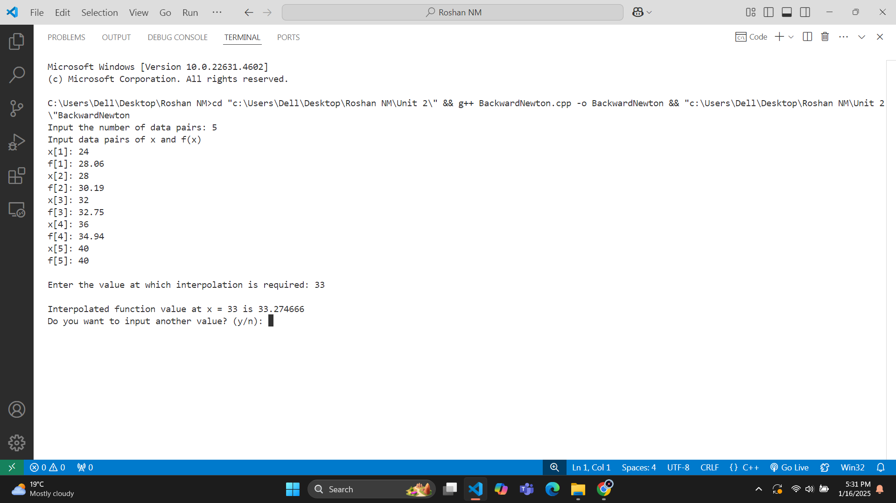**Output:**

|  |  |  |  |  |  |  |  |
| --- | --- | --- | --- | --- | --- | --- | --- |
| X | 0.7 | 0.3 | 0.5 | 0.7 | 0.9 | 1.1 | 1.3 |
| F(x) | 0.003 | 0.067 | 0.148 | 0.248 | 0.370 | 0.518 | 0.697 |

**Input:**

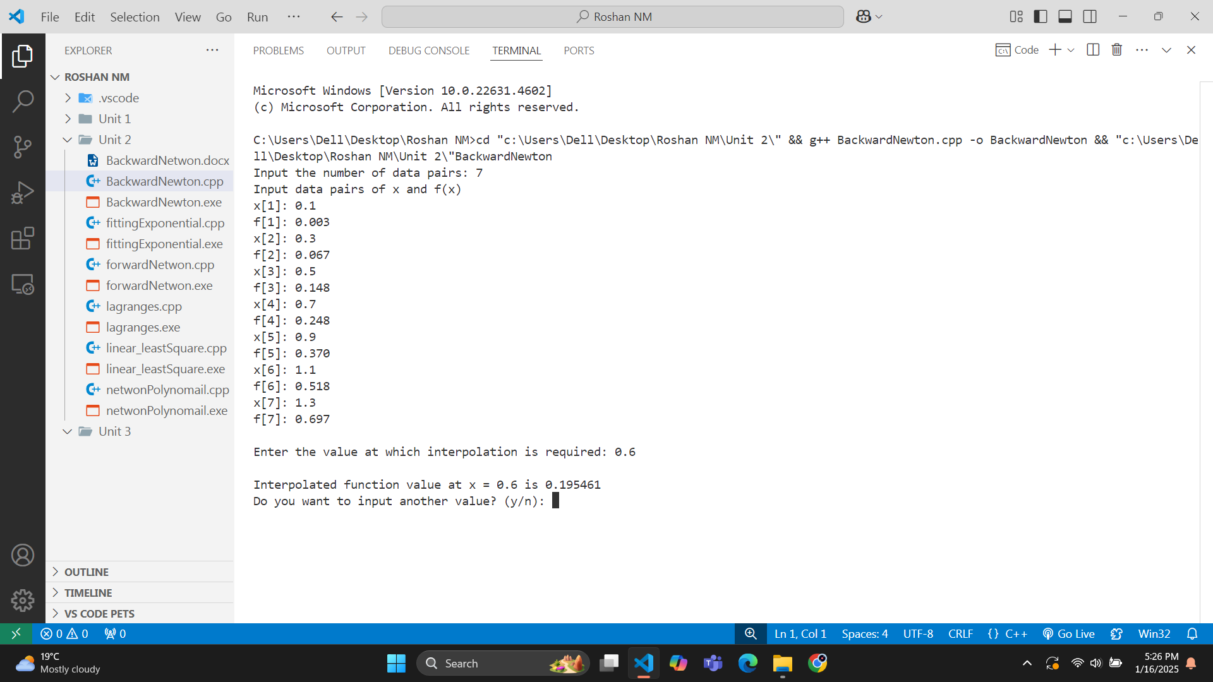**Output:**